DISTRICT OF STREAKY BAY MANAGEMENT PLANS
Caravan and Camping Strategy
dRAFT
February 2024
DISTRICT OF STREAKY BAY MANAGEMENT PLANS
Caravan and Camping Guide
DRAFT
4 September 2023
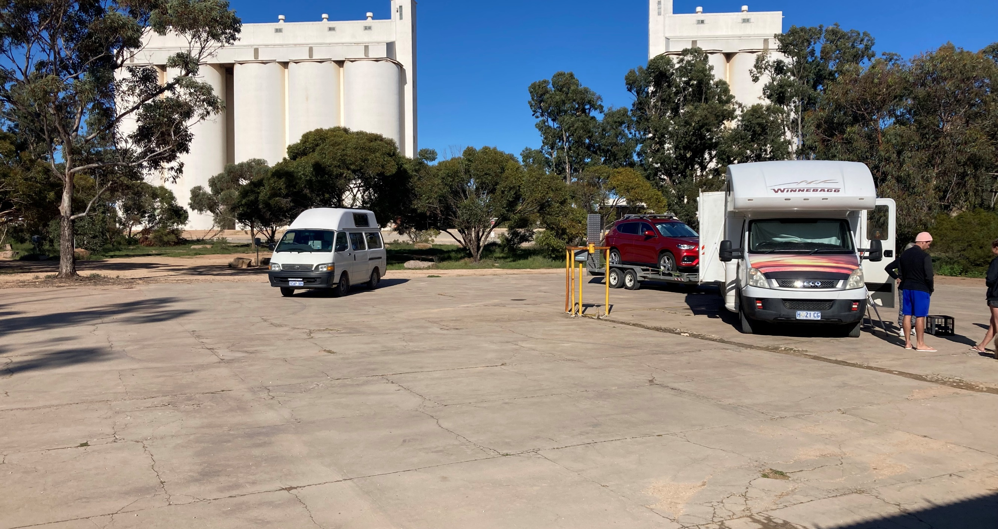


Contents
Introduction 3
Introduction 3
Focus of the Guide 3
Strategic Context 4
Caravan and Camping Principles 5
Analysis of Existing Provision 6
Town Based Formalised Facilities 6
Nature Based Camping Areas 10
Infrastructure to support Caravan and Camping 13
Directions for Caravan and Camping Facility Provision and Upgrade 15
Overriding Directions 15
Directions for Individual Facilities 16
Managing informal Camping 19
Fees and Management 20
Overriding Management Directions 20
Overriding Fee Directions 20
Camping Fees 21
Permit System 21
Requirements for Private Facilities 22
Appendix A - Wirrulla 23
Appendix B - Haslam 25
Appendix C - Perlubie 27
Appendix D – Speeds Point 28

Introduction

Introduction
The District Council of Streaky Bay has a number of existing caravan and camping facilities that are highly valued by visitors and local residents. While the progressive development of many sites has seen significant improvement, there remain opportunities within some facilities that need to be further addressed.
The purpose of the Caravan and Camping Strategy is to guide the approach to the future provision, development and management of caravan and camping facilities and supporting infrastructure in the District Council of Streaky Bay.
The Strategy primarily focused on caravan parks and camping areas located on council-owned or managed land or Crown Land. Specifically, the Guide aims to:
- Recommend the appropriate level of provision and quality
- Guide future improvements to facilities
- Provide a framework for management
- Provide suitable payment and booking systems
The Streaky Bay Caravan and Camping Strategy also provides recommendations for and considers relevance to facilities located on private or perpetual lease land and provides broad requirements for these facilities.

Focus of the Guide
The Streaky Bay Caravan and Camping Strategy includes the following:
- PRINCIPLES for the provision and development of caravan and camping facilities.
- DIRECTIONS for the future provision and development of caravan and camping facilities located within or near towns.
- DIRECTIONS for the future provision and development of nature-based camping facilities located in natural areas.
- Requirements for supporting infrastructure associated with camping and caravanning.

Strategic Context
SA REGIONAL VISITOR STRATEGY
Eyre Peninsula Priorities
- Improve the region’s digital presence and align this with SATC’s digital efforts
- Increase promotion of the region’s competitive strengths and new offerings (coastal, wildlife, seafood, soft adventure, outback, Aboriginal experiences)
- Support the Eye’s on Eyre project, which includes camping, infrastructure, regional trails, wayfinding and signage, Wifi and Visitor interpretation experiences
- Maintain and enhance key coastal infrastructure and national parks including trails for walking and cycling and recreational fishing
- Invest in infrastructure that supports the drive market and encourages overnight stays
- Build on existing partnerships and collateral to drive dispersal to inland and outback Eyre Peninsula
- Increase visitation along the Seafood Frontier touring route and foster dispersal from the route to other parts of the region including inland
- Increase collaboration and alignment of activities across the three tiers of government including RDA EP led projects for greater impact

EP DESTINATION MANAGEMENT PLAN
- Destination Stewardship – A sustainable and transparent approach to tourism management is achieved through engagement with the community, industry and stakeholders to ensure tourism meet the values and needs of the destination
- Marketing – Increase visibility and alignment of the Eyre Peninsula through collaboration with State departments on marketing, PR, travel trade (including responsible travel)
- Collaboration – Tourism stakeholders of the Eyre Peninsula are collaborative, consultative, and strategically aligned, minimising challenges, maximising resources are ensuring visitors have a consistent, quality destination experience.
- Experience and Supply Development – Enhance the appeal of the region and ability to support visitation, through strategic product development and tourism infrastructure.

STREAKY BAY STRATEGIC MANAGEMENT PLAN
- A welcoming and cohesive community
- A robust and adaptive economy that provides sustainable employment
- A healthy natural environment and an attractive built environment
- Infrastructure that meets our community, economic and environmental needs

Caravan and Camping Principles
The GENERAL PRINCIPLES for the provision and development of caravan and camping facilities located on Council owned or managed land or Crown Land are as follows

Topic | Principles
Provision | The provision of additional caravan parks and campgrounds should be market-driven and linked to demand, viability and availability. This may be led by the private sector, as well as by local and state governments.  A small number of good-sized quality nature-based camping areas will be more appropriate than a larger number of small nature-based camping areas. Consideration needs to be given to the capacity of areas to accommodate and meet demand.
Location | Nature-based camping will build on existing camping areas that are linked to recreation and visitor destinations.  New Nature-based camping areas will only be considered under a comprehensive needs analysis assessment.  Caravans and campgrounds will be discouraged in locations that have potential environmental or social impacts or safety risks, such as sensitive vegetation, nesting areas, unstable cliffs, and residential areas.
Quality | All caravan parks and nature based camping facilities located on council-owned, managed land or Crown Land will be matched to the type of camping and caravanning for that area.
Access | Where practical, caravanning and camping facilities should be accessible to all people, including all levels of ability.  Consideration should be given to universal design principles to improve access and usage of facilities by everyone.
Environment | Any improvements to caravan and camping facilities must be sensitive to the natural environment, consider impacts on flora, fauna and the coastal character of the campground and its surrounding environment.  Any improvements to areas around caravan and camping facilities, such as pathway connections and links to parks and beaches, must minimise impacts on the flora, fauna, views and aesthetics of the area. Facilities should minimise erosion or deterioration of the natural landscape character.
Fees and Charges | The application and rate of fees and charges will consider the ongoing maintenance requirements and capital infrastructure installation and/or replacement of the respective sites and required supporting infrastructure.

Analysis of Existing Provision
A summary of existing caravan and camping facilities in the District Council of Streaky Bay is provided below.

Town Based Formalised Facilities
Facility and Location | Description | Issues and Opportunities | Ownership and Management | Fee Structure
Discovery parks Streaky Bay Foreshore (formally Streaky Bay Foreshore Tourist Park), Streaky Bay | Large caravan park with ensuite cabins, units, caravan sites and camping areas (powered and unpowered sites). 26 cabins in total.  Facilities include two camp kitchens, amenities with showers, toilets and laundry, children’s bathroom, TV/ Dining room, kiosk/ restaurant, barbecue area, games room and playground link.  Beach front location with appealing foreshore and Doctors Beach connection. Relatively close to the town centre. | Implementation of the park master plan through the possibility of a 42 year lease which will endeavour to address facility issues and quality.  In consideration of future park expansion with increased bed numbers and infrastructure that supporting services are adequate to ensure expansion can occur.  Varying levels of accommodation and prices should be retained to meet diverse needs of visitation.  Prime beach and foreshore location justify enhancements so the caravan park can meet the requirements of a destination park.  Future sea level rise implications for this site should be considered and potential retreat options identified and planned for. | Council Tourist Park  Council Business under Management Agreement  On site management and staffing.  Crown Land Dedicated to Council | Varying fee structure depending on the facility see website for details.
Streaky Bay Islands Caravan Park, Streaky Bay | Large caravan park with private spacious ensuites cabins. Wide range of facilities including; swimming pool, large modern laundry, disabled bathrooms, recreation room, camp kitchen, fish cleaning and boat motor flush facility as well as a vehicle and caravan wash facility.  Children’s Playground and bike track.  Waterfront location. | New purpose-built facility catering for caravans and tourist accommodation.  High-quality provision with large landscaped sites.  Prime location with waterfront access.  Walking and cycling trails into Streaky Bay.  With further density of population within the overall Little Islands Development area support and facilitate opportunities for local business and supporting infrastructure development.  Continue advocacy to DIT for the potential development of a slip lane onto the Highway | Private Ownership  Private Business  On site management and staffing | Varying fee structures depending on the facility see website for details
RV Friendly Camping Site | Up to 48-hour parking for self-contained motorhomes/caravans (unpowered).  Toilet facilities but no showers.  Suitable for RV’s and motorhomes | Close to the CBD, Doctors Beach foreshore and Community Complex.  No online and manual booking facility is available and site can be subject to space limitation during peak seasons.  Consider opportunities for private management of this site.  Very little amenity (basically reuse of old oval).  Potential to upgrade and develop, tree planting, site delineation, rubble road, toilet upgrade and coin operated showers.  Installation of Dump Point  Investigate opportunities for additional/alternative RV Campground | Crown Land Dedicated to Council  Council managed site.  Consider an online booking system to meet demand and site management.  Consider opportunities for on site or private management agreement | $15 per night fee (honesty box)
Haslam Camping Ground | Open area with space for 12-14 unpowered sites around 100 metres from the foreshore  Toilet located at foreshore | Significant potential to improve amenity and increase the function of campground.  Concept plan (Appendix B) to be reviewed prior to detailed design (masterplan Strategic Action 9).  Opportunities for large vehicle parking.  Distance from the shared toilet located on the foreshore is not ideal. In considering this look at opportunities for continuing to offer shared use facilities rather than separate facilities but with closer proximity to caravan park.  Visitor experiences in Haslam limited consider options from the Haslam Masterplan to improve the visitor experience.  Camping area is relatively small, open, and aesthetically harsh with trees on the perimeter but not across the site.  There is limited connectivity at this location and mobile wifi nodes could be considered | Consider an online booking system to meet demand and site management.  Consider opportunities for on site management (e.g. camphost) | $15 per night fee (honesty box)  Council managed.
Baird Bay Camping Ground | Semi secluded 8 site nature-based camping area on the edge of the town with toilets, gas barbecue, seating and shelter. | Appealing site with good facilities that attract good numbers of users, particularly in the summer season.  The potential of the site is constrained by its size. Ideally it would be larger or have an overflow area.  The location of the site creates difficulties for servicing and local employment opportunities be considered.  Consider delineating existing sites to maximum number of campers.  BBQ and shelter are nearing end of life and needs consideration for replacement.  Limited bore water.  Consider concept design development for site (include options for overflow areas and consideration of sea level rise).  Consideration of Solar Eclipse requirements for 2030, advocate and drive state government investment | Crown Land dedicated to Council  Council engages local business to collect camp fees and undertake cleaning and maintenance of the site.  Consider an online booking system to meet demand and site management. | $15 per night fee – collected by local business under contract.
Wirrulla Camping Area | Hard surface open area with four powered sites, treed surrounds and link to toilets, camp kitchen and a laundry. | Explore opportunities to install additional power heads to adjoining reserve area.  Consult with lessee and continue with master plan upgrades, with consideration to expansion [Masterplan Concept Plan Action 6]  Formalise Entry to Park [Masterplan Concept Plan Action 8]  Consideration of Dump Point and Paid Water Point | Crown Land dedicated to Council.  Community managed under lease agreement.  Consider an online booking system to meet demand and site management. | $15 per night fee (honesty box - fees collected by Progress Association).
Poochera | Caravan and camping area linked to town hotel | Visibility and awareness of Caravan Park limited from highway, opportunities to improve highway signage.  Installation of Dump Point near or privately in the Caravan Park.  Provide business facilitation services to owners if they wish to seek alternative types of accommodation  Improve entry to Caravan Park [Concept Plan Action 1] | Private Ownership  Private Business. | N/A
Perlubie Caravan Park | Smaller scale Caravan Park with powered and unpowered sites. | Support private operators in seeking development approval  Support private operators by providing opportunities for marketing and promotion | Privately Ownership  Private Business | N/A

Nature Based Camping Areas

Facility and Location | Description | Issues and Opportunities | Ownership and Management | Fee Structure
Tractor Beach Camping Area | Native vegetation and dune edge area with link to isolated beach setting and High Cliff viewing area nearby.  10 allocated sites suitable for all types of caravans and campers linked to a road system and two road entrances.  4 allocated sites suitable for tents, campervans and small campers only.  A basic toilet facility is onsite, there are no shower facilities, a small number of bins are provided.  Unpowered sites. | Review the size of the campground as part of a staged development approach with additional sites within sections of lower-value vegetation to the west.  Composting toilet system is labour intensive consider opportunities to retrofit hybrid toilet system.  Monitor site usage and consider coin operated BBQ and showers should site usage be assessed to warrant  5 sites located on Crown Land under short term licence  Seek long term dedication of the entire old site area from Crown Land. | Crown Land under care and control to Council for new site area  Crown Land under annual licence to Council of original campground area  EPLGA managed booking system (https://www.eyrepeninsula.com/camping). | $15 per night fee (online payment and booking)
Speeds Point Camping Area | Open area in front of dunes on the coastal edge with beach connection.  Space for around eight camp sites.  Two separated sections and entrances, one of which is allocated for day visitor car parking.  No toilet or other amenities.  Unpowered sites. | Lack of amenities increases the potential impact on the environment.  Poor site layout limits the number of camping sites.  Redesign to increase number of camping sites and improve the functionality of the space, whilst maintaining the natural character of the area.  Establish a single toilet facility (eco friendly)  Poor connections between the camping and day visitor areas.  Potential to increase camping in the day visitor area.  Revegetate and manage access to the sensitive areas around the site.  Seek long term dedication of the site from Crown Land  Seek funding opportunities for development through Eye’s on Eyre project. | Crown Land with DCSB licence (annual)  Consider an online booking system to meet demand and site management. | $15 per night fee (honesty box)
Perlubie Beach | The camping area is unpowered beach camping only via allocated sites. 30 sites. No camping is permitted in the car park or under shelters. The camping area extends for 600m along the beach. Basic toilet facility as part of the car park. Picturesque location. | Manage sensitive coastal and dune environments.  New online booking and site restrictions has reduced environmental and social impacts on the beach and the local area.  Consider new or upgraded toilet facilities  Erosion control to beach entrance and toilet facility area required  Define through bollard implementation carpark and walkways  Continue maintenance to Perlubie shelters  Complete landswap process to ensure ongoing access to the beach is maintained  Seek long term dedication of the site from Crown Land  Seek assistance and advice from Landscapes SA in activities that support the sustainability of shorebirds along the beach | Crown Land under Annual Licence for Beach Area.  EPLGA managed booking system (https://www.eyrepeninsula.com/camping). | $20 per night fee (online payment and booking)
The Granites Campground, Point Westall | Old campground area located to the South West of the Granites carpark.  Vegetation relatively sparse, rocky area, view of cliff top areas.  Unpowered sites. | Potential to open to 10-15 sites.  Area to be fenced.  Would need toilet installation.  Development of concept plan  Crown Land approval required | Crown Land dedicated to Council  Council managed  Consider online booking system | $15 per night (in line with other campgrounds)
Cape Bauer Loop | Open areas within sand dunes and native vegetation. Situated along the Western side of Cape Bauer Loop with views of the ocean and within close proximity to coastline, boardwalks and beaches | Potential for eco-cabin style development  Potential for small RV style nature based campground  Potential for supporting infrastructure such as bush walks  Develop concept plan for site | Council Owned | N/A

Infrastructure to support Caravan and Camping
Facility and Location | Description/Issue | Opportunities
Wirrulla | No RV Dump Point  Heavy and Long Vehicle Parking in and around campground  Use of taps for filling up water – cost of water supply  Maintenance costs of two amenities blocks  Safety concerns – pedestrian crossing between park and campground  Lack of Visitor Experiences | Explore opportunities for Dump Point [Masterplan Strategic Action 11]  Explore opportunities and appropriate location for heavy/long vehicle parking [Masterplan Concept Plan Action 9]  Installation of paid water meter  Dual sided entry new Amenity Block [Masterplan Concept Plan Action 5]  Create Pedestrian Crossing Point [Masterplan Concept Plan Action 13]  Formal Walking Trails and Bicycle Track Linkage [Masterplan Concept Plan Action 19]  Upgrade Playspace to support Caravan/Camping [Masterplan Strategic Action 9]  Wirrulla Inland Jetty Area Developed [Masterplan Strategic Action 7]
Poochera | No RV Dump Point  Heavy Vehicle Parking in and around Caravan Park  Use of taps for filling up water – cost of water supply  Lack of Visitor Experiences | Explore opportunities for Dump Point [Masterplan Strategic Action 16]  Explore opportunities and appropriate location for heavy vehicle parking [Masterplan Concept Plan Action 4]  Explore opportunities for Installation of paid water meter  Ant Entry Statement [Masterplan Concept plan Action 4]  Footpath connections between Caravan Park and Attraction [Masterplan Concept Plan Action 18]
Haslam | Public Toilet also used for Campground  Boat Washing Down  Limited boat parking for day boat users  Boat Ramp Condition at certain times of the year  Use of taps for filling up water – cost of water supply  RV Dump Point in vehicle path to Boat Ramp  Lack of Information Signage  Condition of Jetty and surrounding areas  Limited connectivity | Explore community/visitor preference and ongoing sustainability of shared amenities or separate public and campground amenities.  Consider planning for Boat washing  Increase and develop areas for Boat Parking [Concept Plan Action 7]  Maintain function of Boat Ramp [Strategic Action 13]  Installation of paid water meter [Concept Plan Action 3]  Consider relocation of RV Dump Point to outside Caravan Park [Strategic Action 15]  Information Bay Development (Concept Plan Action 3]  Maintain access to and under Jetty [Strategic Action 6]  Consider Installation of Wifi Node to provide Connectivity
Perlubie | No RV Dump Point  Toilet water – over usage  Toilet Septic – use of soakage for septic in environmental sensitive area  Camping in Car Park  Shelters – ongoing maintenance and camping under shelters  Staircase – from cliff top to Beach  Limited Connectivity  Shorebird Interuption and sustainability  Beach Access – Privately Owned | Consider opportunities to partner with private developers for RV Dump Points  Explore viability of retrofitting hybrid system to toilet and/or refurbishment of existing toilets  Continue to maintain no camping in Carpark to allow for day use  Continue to maintain shelters and availability for day use  Monitor condition of stair case and plan for replacement  Consider Installation of Wifi Node to provide Connectivity  Interpretive signage and investigate seasonal exclusion zones  Complete Landswap to ensure ongoing Beach Access
Little Islands | Intersection with Highway is a safety Concern  Micro Business Development | Advocate to DIT to install a Slip Lane on Highway  Support whenever possible Business Development Opportunities

Directions for Caravan and Camping Facility Provision and Upgrade
Recommended directions for the future provision of and improvement to caravan and camping facilities are outlined below. This includes overriding directions and directions for specific facilities.

Overriding Directions
Caravan Facilities
- The Streaky Bay Foreshore Tourist Park should continue to be a high-quality facility that caters for diverse caravan and camping requirements and draws people to the district and the town of Streaky Bay (as the district’s main centre).
- Caravan and camping facilities should be developed in Streaky Bay to existing demand and provide alternative locations in response to sea level rise and other climatic impacts.
- Caravan and camping facilities should be retained on Council or Crown Land under Council’s care and control in Haslam, Baird Bay and Wirrulla, facilities shall match the desired type of camping for each location.
- The existing Haslam, Baird Bay and Wirrulla caravan and camping facilities will require ongoing master planning and upgrades.
- Caravan and camping facilities on Council or Crown Land in other towns (i.e. besides Streaky Bay, Haslam, Baird Bay and Wirrulla) will not be appropriate, unless they replace existing private facilities.
- Support private caravan and camping facilities through strategic planning and promotion to maintain a range of facilities that meet tourist demands.
- Support business development and assist in facilitation where appropriate for privately operated caravan and camping opportunities.

NATURE BASED CAMPING
- Continue to manage, upgrade and master plan existing designated nature-based camping facilities of Tractor Beach and Speeds Point (which are at key locations along the popular Westall Way Loop Drive).
- Designated nature-based camping along the Cape Bauer Loop Drive to be reviewed as part of a broader master planning process for Cape Bauer. Consider the impacts of close proximity to the town of Streaky Bay.
- All designated nature-based camping areas should have defined camping areas, environmentally responsive facilities, a toilet and sensitively designed signage as a minimum.
- Nature-based camping areas should be designed to manage impacts on the environment, including defined campsites, defined walking tracks to the amenities, beach and viewing areas, and minimal road and entrance points.
- Designated nature-based camping is unlikely to be required at other Council or Crown Land locations due to the provision of camping facilities near the towns of Sceale Bay and Baird Bay. This is unless there is a future desire by DEW to establish designated nature-based camping with amenities in Conservation Parks for commercial or other reasons.
- Nature based camping areas could include a water tank (linked to toilets) in the future if appropriate.
- Nature-based camping areas should use online booking systems to manage demand and payment of fees.

Directions for Individual Facilities
Directions for individual caravan and camping facilities located on Council or Crown Land are provided below.
Facility and Location | Action | Priority | Timeframe
Streaky Bay Foreshore Tourist Park | Continue to negotiate and pursue boundary realignment and purchase of crown land on which the caravan park is located to ensure revenue continues over a long period of time. | High | 2023/2024
Streaky Bay Foreshore Tourist Park | Explore possibilities to negotiate Long Term Lease with private providers, with inclusion of conditions to development masterplan and include infrastructure development. | High | 2024/2025
Streaky Bay Foreshore Tourist Park | Within Park Masterplan Consideration of future sea level rise in all future planning for site and explore potential areas suitable for coastal retreat. | Medium | Ongoing
Little Islands Caravan Park | Advocate to DIT for the Installation of a Slip Lane to Little Islands Rd/Highway Intersection | Medium | 2024/2025
Future Streaky Bay Camping and Caravan Sites | Include within master plan for Streaky Bay opportunities for new sites. | High | Ongoing
Future Streaky Bay Camping and Caravan Sites | Where appropriate undertake further investigation and develop business case(s) for development of new sites. | Medium | Ongoing
Future Streaky Bay Camping and Caravan Sites | Consider the impacts of sea level rise and climate changes when master planning future sites. | Medium | Ongoing
Future Streaky Bay Camping and Caravan Sites | Consider opportunities for the private management of the RV Park. | High | 2024/2025
Future Streaky Bay Camping and Caravan Sites | Development of Masterplan Cape Bauer Loop including Camping and Caravanning Activities. | High | 2024/2025
Haslam Camping Ground | Refer to Concept Plan in Masterplan (Appendix B) for future development of site | High | 2023/2024
Haslam Camping Ground | Undertake appropriate consultation for Campground Concept Detailed Design | Medium | 2025/2026
Haslam Camping Ground | Develop online booking system to meet demand and site management. | High | 2024/2025
Haslam Camping Ground | Investigate options and viability of a kiosk | Low | 2026/2027
Haslam Camping Ground | Consider on site management options (e.g. Camp Hosts) | Medium | 2024/2025
Wirrulla Camping Ground | Enhance the adjoining play space to cater for visitors with children and the local community (refer to Appendix A). | Medium | 2025/2026
Wirrulla Camping Ground | Enhance the visual and landscape connection to The Triangle reserve in negotiation with Native Title Holders | Medium | 2025/2026
Wirrulla Camping Ground | Consider further beautification of this site and further facilities and connectivity | Medium | 2025/2026
Wirrulla Camping Ground | Develop online booking system to meet demand and site management | Low | TBC
Wirrulla Camping Ground | Ensure that under current management arrangements appropriate data and occupancy is obtained to enable future capacity and infrastructure planning | High | Ongoing
Wirrulla Camping Ground | Continue management via private/community organisations | High | Ongoing
Baird Bay Camping Ground | Develop concept plan for site that considers and includes opportunities for items below | High | 2024/2025
Baird Bay Camping Ground | Delineate the sites within the camping ground to increase the potential number of users of the existing site. |  | TBC
Baird Bay Camping Ground | Investigate the potential to formalise an overflow area across the road. | High | 2024/2025
Baird Bay Camping Ground | Consider demand and market in determining future amenities and infrastructure within the concept plan | High | 2024/2025
Baird Bay Camping Ground | Develop online booking system to meet demand and site management | Medium | 2024/2025
Baird Bay Camping Ground | Replace BBQ at end of Asset Life | High | 2024/2025
Baird Bay Camping Ground | Replace toilet at end of asset life | Medium | TBC
Baird Bay Camping Ground | Investigate alternative Management Options | High | 2023/2024
Tractor Beach | Provide quality additional interpretive signage. | Low | 2024/2025
Tractor Beach | Define some appropriate tracks to the beach. Collaborate with State Government to realise the pathway to High Cliff identified in the EP Regional Trails Strategy. | Low | 2025/2026
Tractor Beach | Revegetate and manage access to the sensitive natural areas around the site. | Medium | 2024/2025
Tractor Beach | Consider future installation of coin operated BBQ | Low | 2025/2026
Tractor Beach | Toilet – convert to Hybrid from composting to reduce labour intensity of maintenance | High | 2023/2024
Speeds Point | Undertake a concept plan to consider the following site improvements; Redesign the two camping areas to increase the number of camping sites and improve the function of the total space (refer Appendix D). | High | 2023/2024
Speeds Point | Investigate and pursue opportunities for additional sites either behind current campground or in turning circle area on opposite side of the road. | High | 2023/2024
Speeds Point | Establish a single toilet in an appropriate location that is compliant with relevant planning regulations. | High | 2023/2024
Speeds Point | Install appropriate signage providing direction and restrictions to camping on the site. | High | 2023/2024
Speeds Point | Restrict vehicle access to the actual Point (with large boulders or bollards). | High | 2023/2024
Speeds Point | Revegetate and manage access to the sensitive natural areas around the site. | High | Ongoing
Speeds Point | Maintain the natural character of the area (with minimal development and well sited signs and amenities). | High | Ongoing
Speeds Point | Council to negotiate care and control of this site. | High | 2023/2024
Perlubie | Refer to Concept Plan from Masterplan Document (Appendix C) | High | 2023/2024
Perlubie | Modify and upgrade car park including:  - Bollards to define car park  - Turnaround area  - Closure of informal parking area  - Formalise parking including large vehicle area  Informal boat and trailer parking | High | 2023/2024
Perlubie | Improve and manage beach access | High | 2023/2024
Perlubie | New or refurbished toilet set back from beach to improve visual amenity of dunes and increase storm resilience | High | 2024/2025
Perlubie | Provide information signage display and temporary parking for viewing | High | 2023/2024
Perlubie | Consider overspill parking and tyre pressure check area along entry road | Medium | 2024/2025
Perlubie | Complete Landswap Agreement to ensure continued Access to the Beach | High | 2023/2024
Perlubie | Review strategic planning and feasibility of designated private camp site at Perlubie to support existing and future demand. | High | Ongoing
Poochera Camping Ground | In consultation with owners improve entry to caravan park | Medium | 2024/2025
Poochera Camping Ground | Investigate signage opportunities to increase visibility of the park | Medium | 2024/2025
Poochera Camping Ground | Seek opportunities and support owners in seeking additional funding for short term accommodation | Medium | Ongoing
Eyre’s Waterhole | Liaise with DIT to establish continued relevance of camping at this location given proximity to Streaky Bay Township | High | 2023/2024
Eyre’s Waterhole | Assist with implementation of any appropriate measures to restrict or discourage camping at this location | High | 2023/2024

Managing informal Camping
Camping in non-designated camping areas (informal camping) is likely to occur where people are self-contained, or they wish to be near an activity, such as a remote fishing spot, or get away from other campers.
The Eyre Peninsula Coastal Action Plan identifies the impact that informal camping can have on natural areas:
“Much of the Eyre Peninsula coast is subject to informal camping, which often occurs in sensitive areas, such as native vegetation, sand dunes or cliff tops… As informal camping areas do not provide any facilities, there is an increased risk of impact on the surrounding environment, e.g. from waste (including human waste), wildlife and vegetation disturbance or destruction and soil disturbance. Informal camping is also often linked to increased Off-Road Vehicle tracks.”
It is difficult to avoid informal camping, and rather than place a ban on informal camping, it would be better to manage and limit this activity.
This could be achieved by developing online information and brochures with maps that:
- Identifies and encourages the use of designated camping areas
- Identifies areas that are strictly ‘no camping’
- Provides hints on responsible camping
- Outline the environmental and social impacts of ‘wild camping’
Informal camping could be allowed in the dune area at Fisherman’s Beach and Yanerbie Sandhills (existing popular places for camping by the locals) if access to the dune areas by vehicles is managed. It will be important to minimise vehicles moving across the dunes to strengthen the stability of the dunes. (confirm wild camping is allowed in these locations).
Council to continue to lobby and advocate the State Government for camping restrictions to sensitive areas of Crown Land (changes to the Crown Land Act).

No Camping
It is suggested that the following sites be considered as ‘no camping’:
- The Spit area of Gibson’s Peninsula (private property – out of council control)
- Cape Bauer (subject to Crown Land Act)
- Cape Blanche (Subject to Crown Land Act)
- High Cliff (private property/Crown Land area pedestrian access only)
- Smooth Pool (subject to Crown Land Act)
- Point Labatt (subject to crown land)
- Cape Radstock (private property)
- Eba Anchorage Beach
- Eyre’s Waterhole (Cooyeanna Well) – DIT
‘No camping’ sites could be promoted through online information, brochures and signage at specific locations.

Fees and Management

Overriding Management Directions
In relation to caravan and camping facility management, it is recommended that:
- The Streaky Bay District Council should continue to own and investigate long term management option for the management of the Streaky Bay Foreshore Tourist Park. This could involve Council outsourcing the management to a third party providing social and environmental commitments are maintained.
- Communities should continue to play a key role in the management of caravan and camping facilities located in Haslam, Baird Bay and Wirrulla providing the services and management occur within the context of this Caravan and Camping Guide.
- All designated nature-based camping areas located on Crown Land should be managed by the Streaky Bay District Council, with the exception of designated nature-based camping areas in Conservation Parks if these are established in the future (these would be managed by DEW or a body appointed by DEW).
- To enable management of the nature-based camping areas by Council the Crown Land should be dedicated to the care control and management of Council through a lease arrangement if this does not already exist.

Overriding Fee Directions
In relation to caravan and camping fees, it is recommended that:
- A consistent and equitable fee structure is put in place for all caravan and camping facilities located on Council or Crown Land. The fee structure should reflect the level of amenity and the level of maintenance required to provide facilities and related services.
- The Streaky Bay Foreshore Tourist Park should continue to have its own fee structure as an independent commercial operation.
- The fee structure outlined in this guideline should be used to set fees for all other caravan and camping facilities and services.
- Fees obtained through community and bush caravanning and camping facilities, i.e. not including fees from the Streaky Bay Foreshore Tourist Park, should be allocated to the ongoing maintenance and improvement of the facilities.
- A permit system should be established to collect fees for all community and bush caravanning and camping areas excluding the Streaky Bay Foreshore Tourist Park. Details are included in the suggested fee schedule on the following page.

Camping Fees
A guide for developing a fee schedule for caravan and camping facilities located on Council or Crown Land is provided below based on industry examples and taking the existing and types of facilities into consideration.
It is suggested that fees are based on the following categorisation of facilities:
- Major caravan and camping facility, e.g. Streaky Bay Foreshore Tourist Park
- Community caravan and camping grounds, e.g. Haslam, Baird Bay Wirrulla, Tractor Beach, Perlubie camp grounds
- Nature based designated camping areas, e.g. Speeds Point camping areas.
The fees could be charged on a ‘per site’ basis.
It is recommended that the specific fee amounts are determined by the District Council of Streaky Bay and reviewed by Council every two years in accordance with Council’s Annual Business Plan.
In setting fees analysis should be undertaken against other Eyre Peninsula campgrounds with a view to working towards a standardised fee system that is consistent across the Eyre Peninsula.
Ongoing consideration could be given to CPI and management and upgrade costs.
Payment and management of the fee could be by a permit system as outlined.

Permit System
A permit system is suggested for the Community Facility camping and Nature-Based camping to avoid the issue of having to physically collect payments, people not paying through the ‘honesty system’ or money being stolen.
The permit system could involve people booking for a certain number of days or a period of time to undertake caravanning or camping in the Streaky Bay District. All sites should eventually move to the EPLGA based “Book Easy” online booking system.
The Permit options could be as follows:
- Daily rate (as per the fee schedule and relates to the number of days required)
- Weekly rate (this is difficult to manage in Book Easy)
The permits could be purchased online and issued digitally. The permits could be assigned to car registrations or mobile phones and geo-referenced to the camp sites.
Monitoring compliance with the permit system would require regular checks by Council officers and park rangers. A fine system may need to be adopted to encourage compliance.

Requirements for Private Facilities
Requirements for private caravan and camping facilities are as follows:
- The facility operator must have a development approval to operate the facility as a commercial business under the State Planning and Design Code. This includes formalising any existing camping facilities that may not have approval to operate.
- Any improvements to the facility must be approved through the Development Application process as appropriate. This includes existing camping facilities having development approval for current facilities.

Appendix A - Wirrulla
District Council of Streaky Bay Township Management Plans – Wirrulla Concept Plan Extract
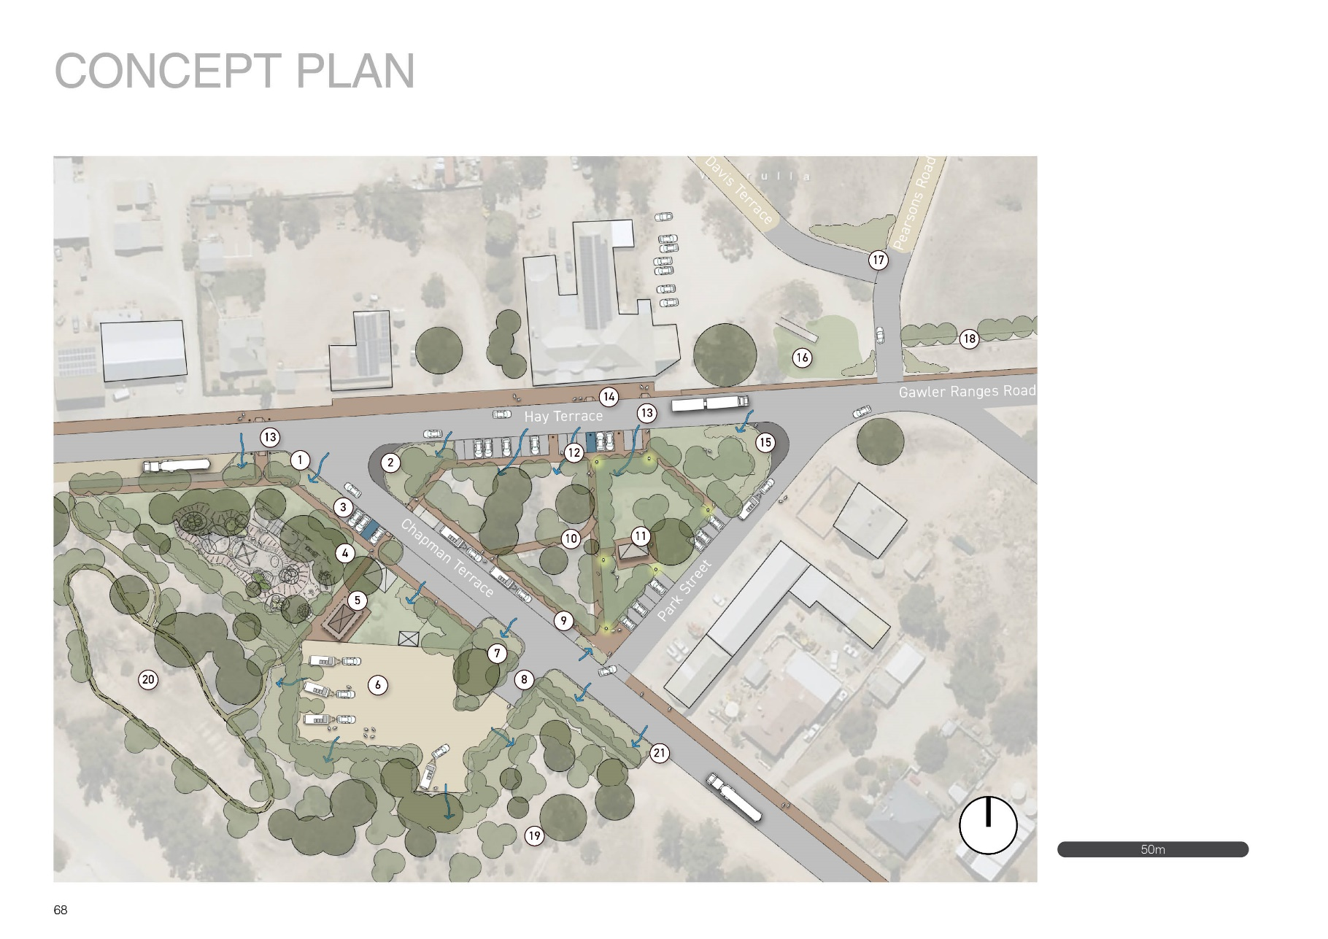

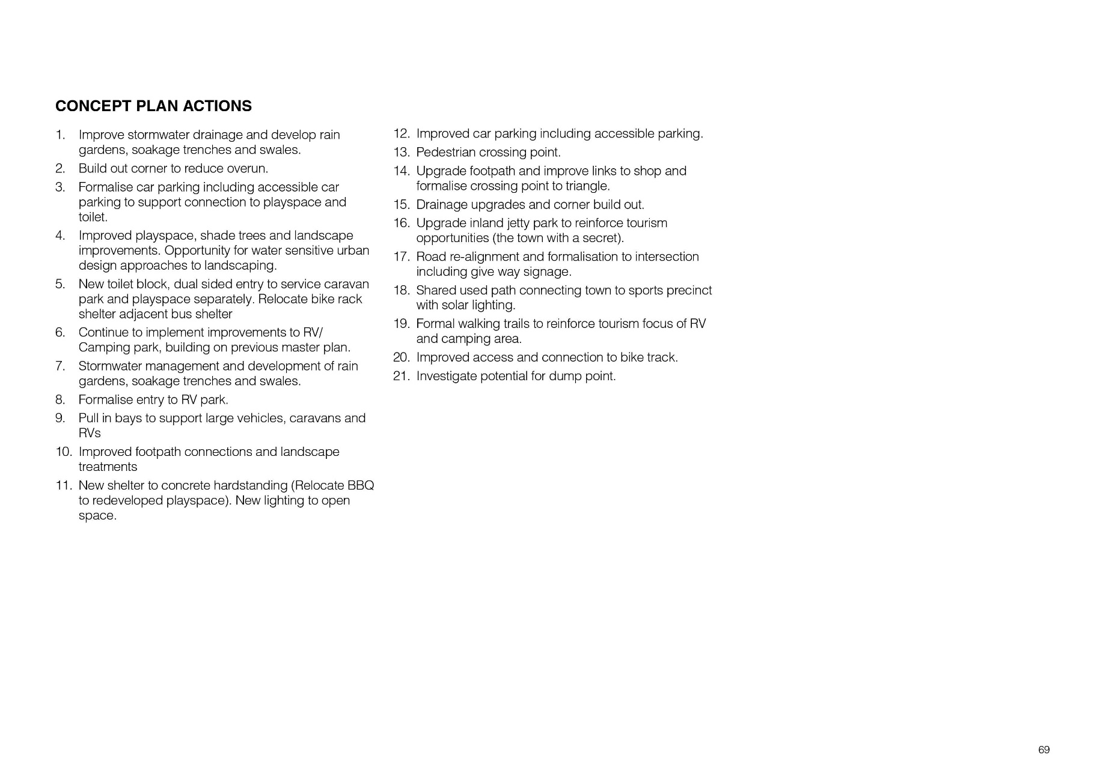

Appendix B - Haslam
District Council of Streaky Bay Township Management Plans – Haslam Concept Plan Extract
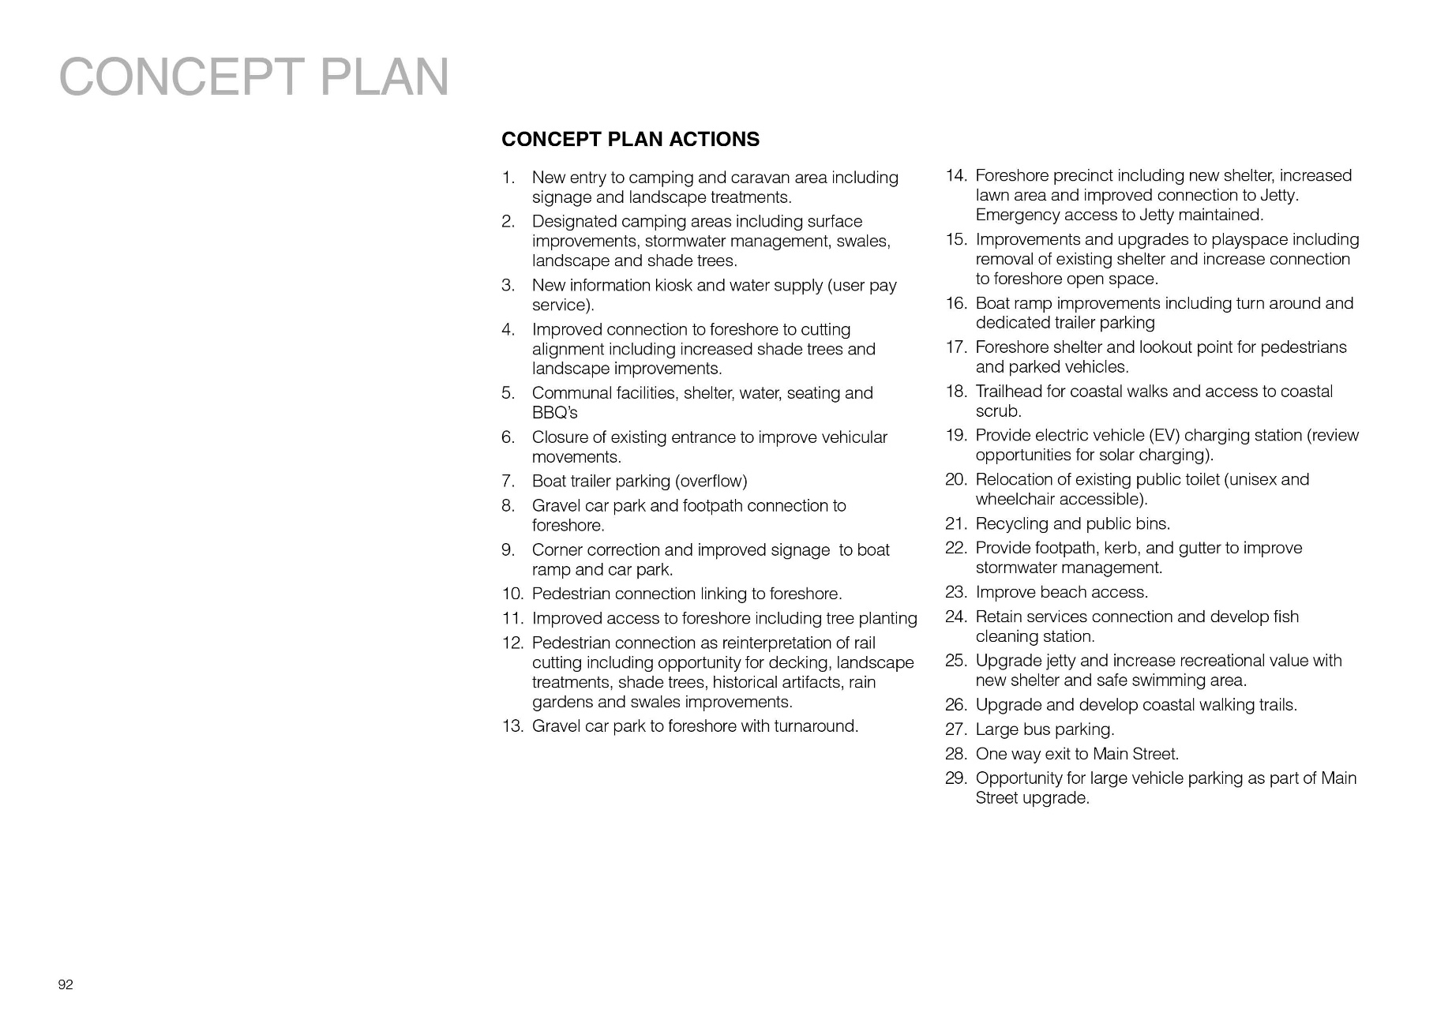

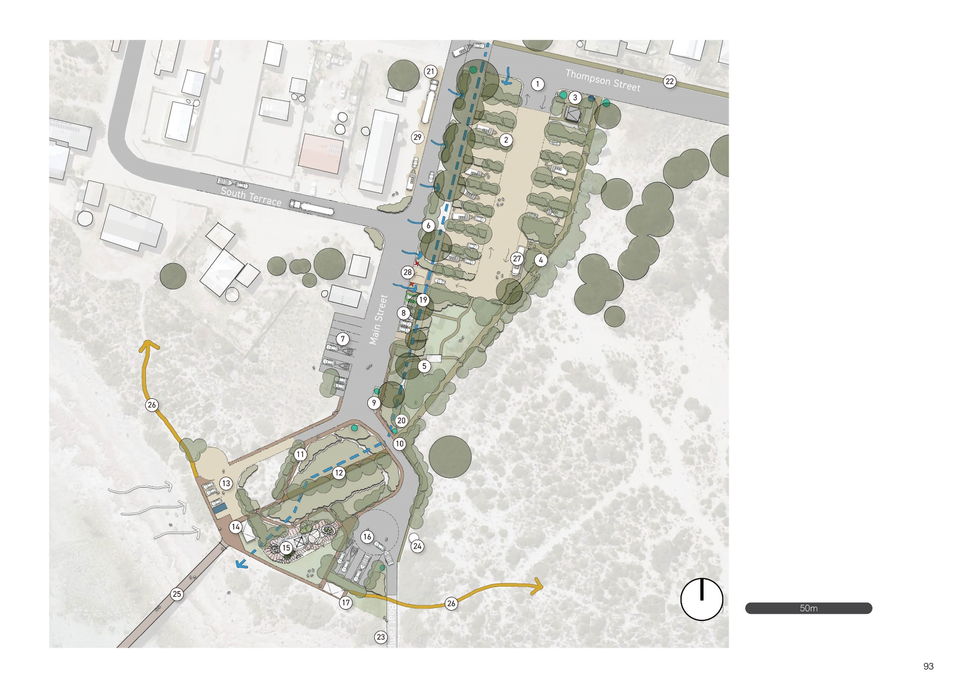

Appendix C - Perlubie
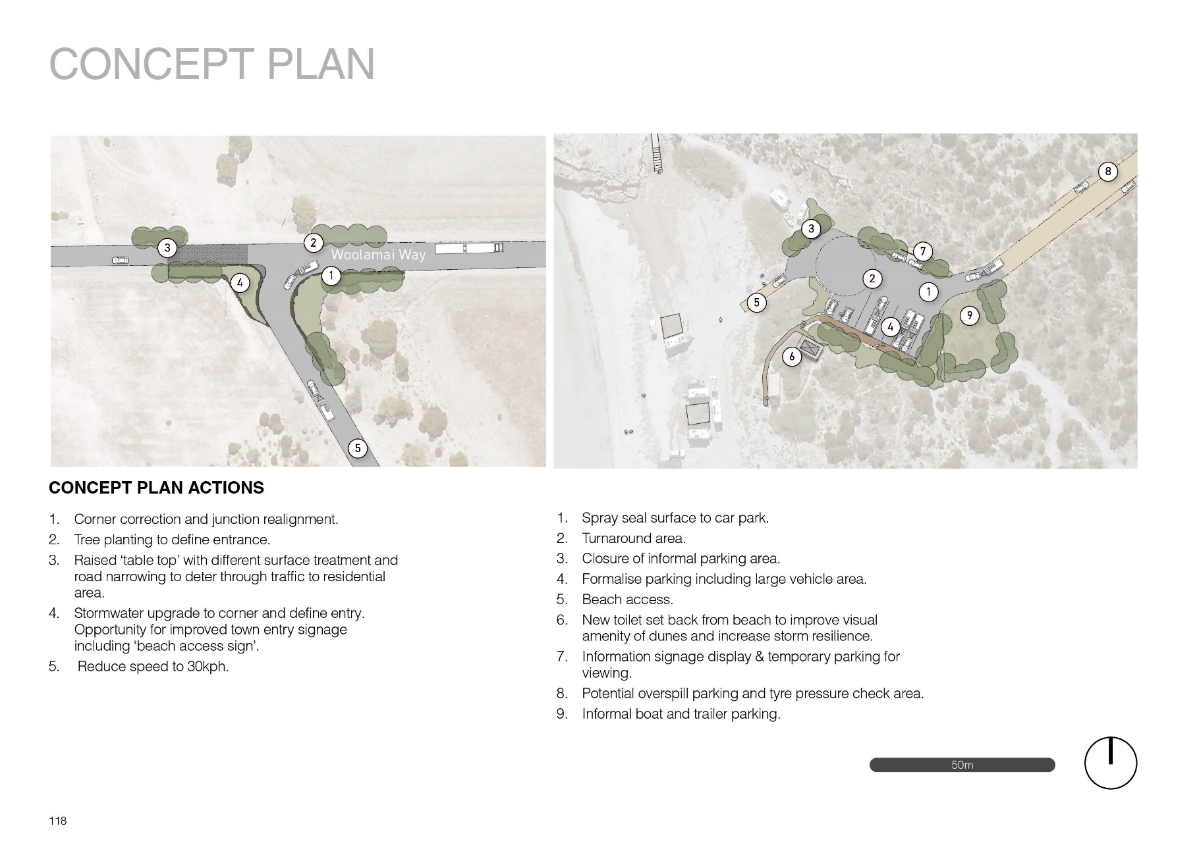
District Council of Streaky Bay Township Management Plans – Perlubie Concept Plan Extract

Appendix D – Speeds Point
